Maya 3.0 → Half-Life SMD File Exporter
Written by Escape Factory, Ltd.
9/27/00

Instructions for using the Maya exporter
This exporter will allow you to generate SMD files for use with the Half-Life engine from characters built and animated in Maya. This document assumes that you are already familiar with the process of building and compiling characters for Half-Life using 3D Studio. You should first read the excellent tutorial “Modeling for Half-Life” also included in this tutorial.

Export Limitations
You may use any of the animation tools within Maya to animate your character, but you must observe the following constraints when modeling:

- Your character’s skin must be a single polygon mesh.
- Every polygon on your mesh must have a UV mapping.
- Each texture must be an 8-bit-indexed bitmap image – no procedural shaders or vertex colors. If you want to use simple colors, then create a 2x2 bitmap of the color you want to use and apply that as a texture.
- Your skeleton must have exactly one root bone.
- You must use the “soft skin” technique to attach your skin to your skeleton. One way to do this is to select both your skeleton and your skin, then choose “Skin->Bind Skin->Smooth Bind” from the menu. Since Half-Life supports only rigid binding, however, for best results we recommend making sure that each vertex is bound to only one bone. If the exporter finds a vertex bound to more than one bone, it will choose the bone with the strongest binding and ignore the others. You can force this by selecting your skeleton and using the prune weights command (skinPercent –prw [skin cluster node] [quantize value]) where the quantize value is something high, like .99 – this will force all weightings of less than .99 to zero (and renormalize all higher weightings to 1).
- Remember that scale transforms will not be reflected in Half-Life. Don’t animate the scales of any objects in your scenes.

Installing the Maya Exporter:
- Copy the “SmdExport.mll” file from the SDK into your “Maya3.0\bin\plug-ins” directory.
- Copy the “smdExportOptions.mel” file from the SDK into your “Maya3.0\scripts\others” directory (or any other script directory).
- Start Maya, and launch the plug-in manager:
“Window->Settings/Preferences->Plug-in Manager”
- Locate SmdExport in the list of Plug-ins and select the “loaded” and “auto load” check boxes. This will make sure the Smd exporter is loaded every time.

Using the Maya Exporter:
- To create an SMD from within Maya, load the character’s scene into Maya and then choose “File->Export All”. If the Maya Exporter has been loaded correctly then you should see “.SMD” listed as one of the available file types.
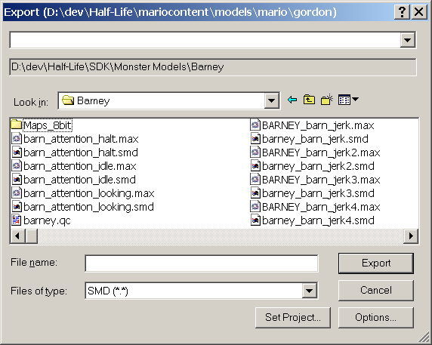
Note:
SMD file type listed

- Select whether you are exporting a reference file or an animation file from the options menu. Click the “Options” button, select the “SMD” file type, and choose the appropriate option.

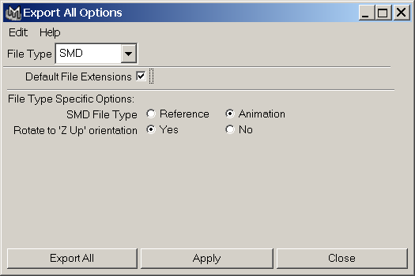
Generate reference file
Generate animation file
Choose if you used the Maya default “Y Up” orientation

- Maya’s default world orientation is “Y-Up” whereas the Half-Life engine assumes “Z-Up”. You will need to choose the “Rotate to ‘Z Up’ orientation” option if you used the default “Y-Up” orientation in Maya.
- Click “Apply” to save your options.
- From the “Export” file dialog, select the SMD file type, give your file a name, and click “Export”.

